**HANDLING REQUEST FOR GET,POST,PUT AND DELETE: 1. Create a NodeJs/Express RestAPIs project:**

/nodejs-restapi

/app

/controllers

customer.controller.js

/routes

customer.routes.js

/node-modules

package.json

package-lock.json

server.js

**2.The project create a set of Rest-APIs for POST/GET/UPDATE/DELETE APIs:**

/api/customers – GET all customers

/api/customers/:id – GET a customer by Id

'/api/customers – POST a customer

/api/customers/update/:id – UPDATE a customer by Id

/api/customers/delete/:id – DELETE a customer by Id

**3. Create application directory:**

mkdir nodejs-restapi

cd nodejs-restapi

**4. Create package.json file:**

Press ^C at any time to quit.

package name: (nodejs-restapi)

version: (1.0.0)

description: NodeJs-RestApis

entry point: (index.js) server.js

test command:

git repository:

keywords: NodeJs-RestAPIs

author: JSA

license: (ISC)

About to write to C:\Users\pc\Desktop\nodejs\nodejs-restapi\package.json:

{

"name": "nodejs-restapi",

"version": "1.0.0",

"description": "NodeJs-RestApis",

"main": "server.js",

"scripts": {

"test": "echo \"Error: no test specified\" && exit 1"

},

"keywords": [

"NodeJs-RestAPIs"

**],**

"author": "JSA",

"license": "ISC"

}

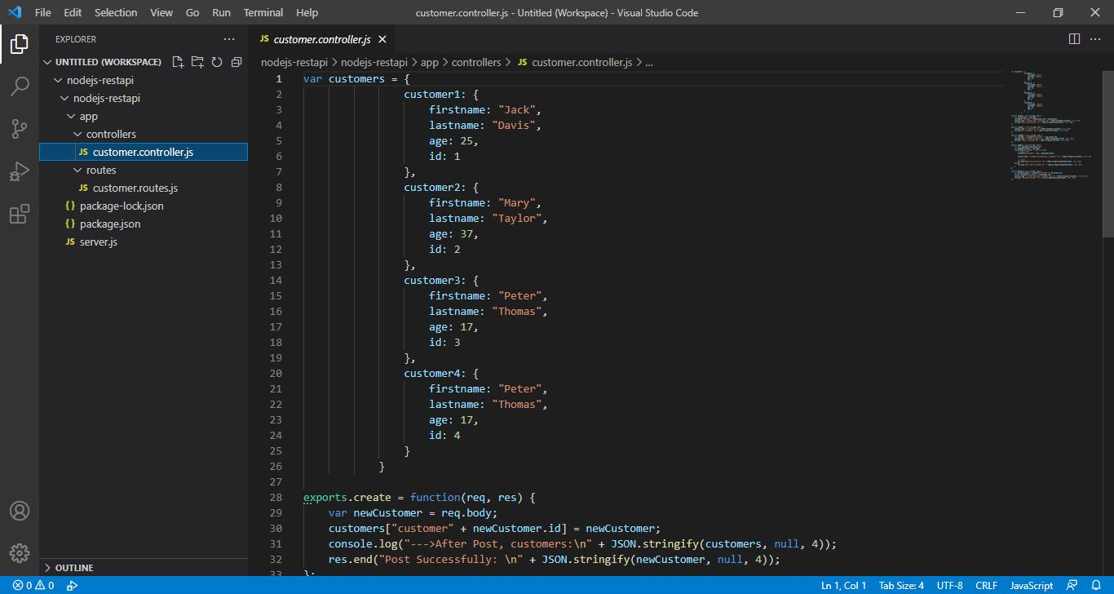

**5. Install express and body parser:(content in .json file)**

{

"name": "nodejs-restapi",

"version": "1.0.0",

"description": "NodeJs-RestApis",

"main": "server.js",

"scripts": {

"test": "echo \"Error: no test specified\" && exit 1"

},

"keywords": [

"NodeJs-RestAPIs"

],

"author": "JSA",

"license": "ISC",

"dependencies": {

"body-parser": "^1.18.2",

"express": "^4.16.3"

}

}

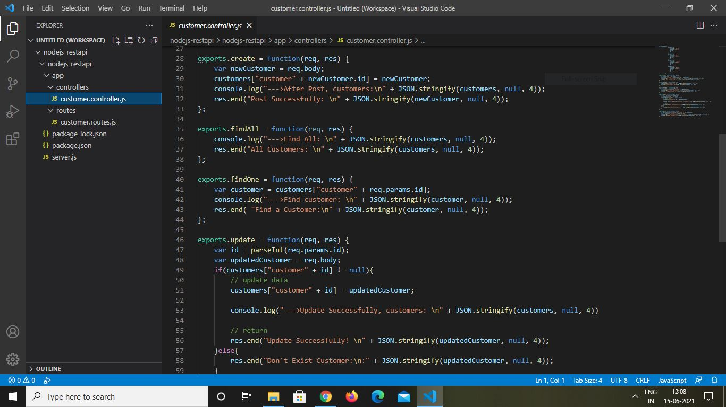

**6. Implement nodeJs and Express APIs**

In root folder ‘nodejs-restapi’, create a ‘server.js’ file:

var express = require('express');

var app = express();

var bodyParser = require('body-parser');

app.use(bodyParser.json())

require('./app/routes/customer.routes.js')(app);

// Create a Server

var server = app.listen(8081, function () {

var host = server.address().address

var port = server.address().port

console.log("App listening at http://%s:%s", host, port)

})

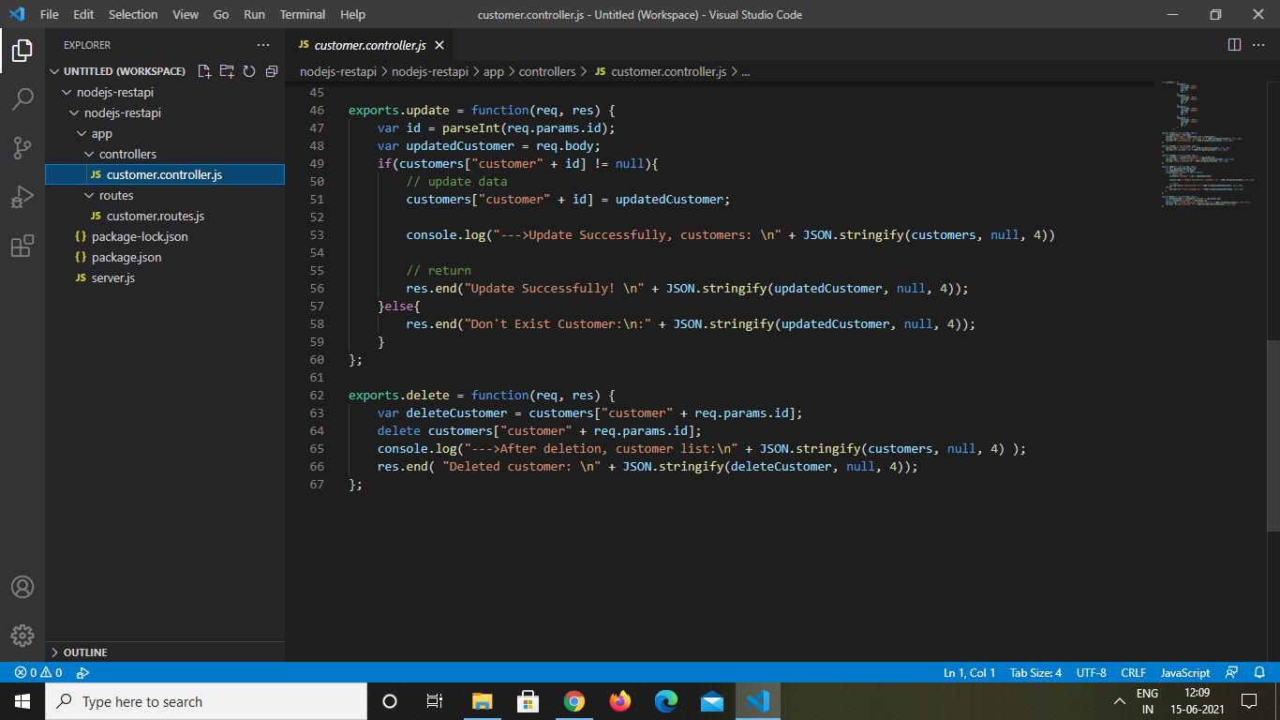

**7. Implement Express Appliication (Routers):**

module.exports = function(app) {

var customers = require('../controllers/customer.controller.js');

// Create a new Customer

app.post('/api/customers', customers.create);

// Retrieve all Customer

app.get('/api/customers', customers.findAll);

// Retrieve a single Customer by Id

app.get('/api/customers/:id', customers.findOne);

// Update a Customer with Id

app.put('/api/customers/:id', customers.update);

// Delete a Customer with Id

app.delete('/api/customers/:id', customers.delete);

}

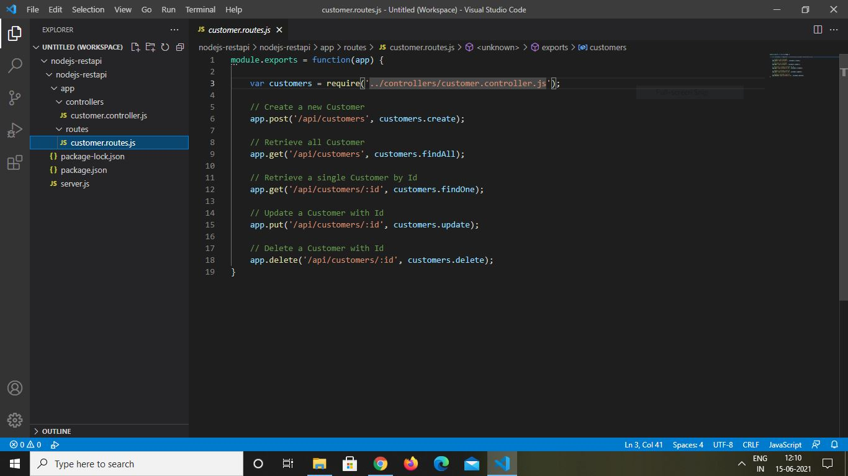

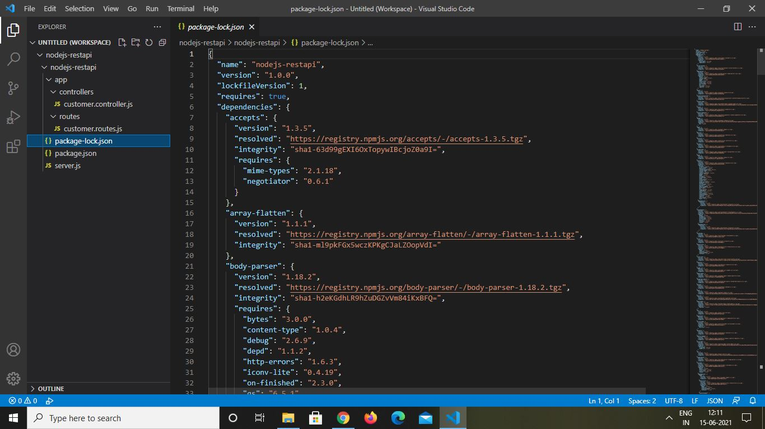

**8. Controllers:**



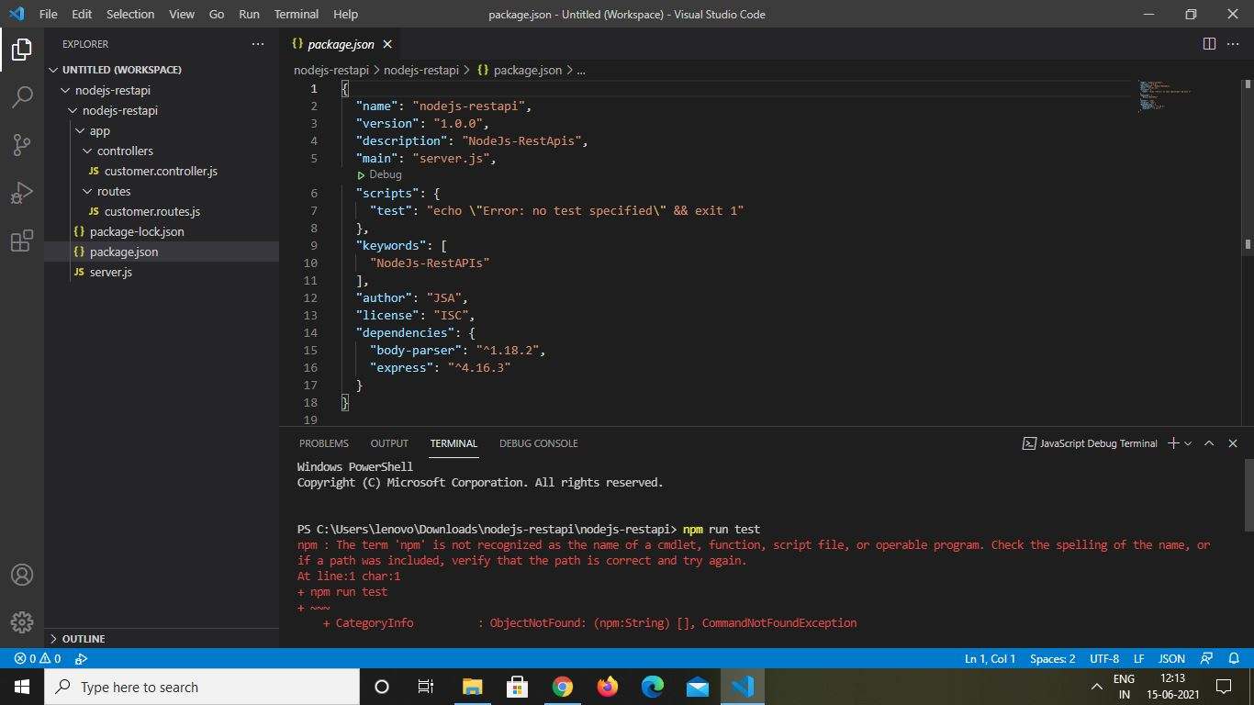

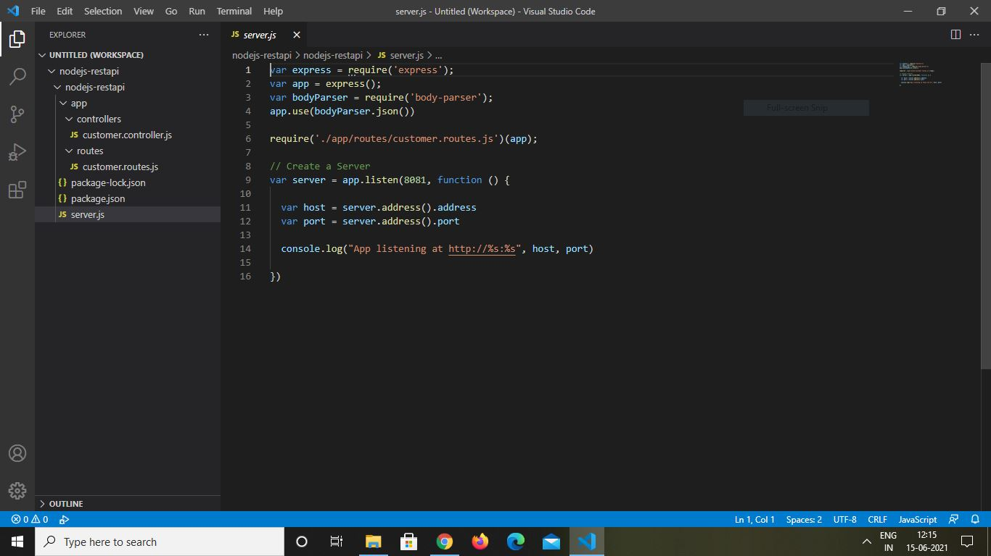

**TEST RESULTS:**

Use postman to check results:

1. Get :

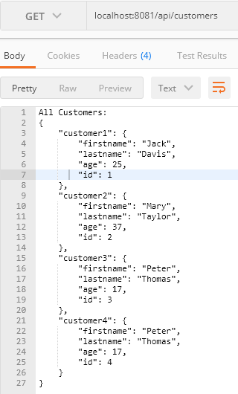

Get an employee id:

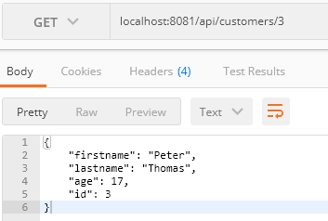

1. Post :

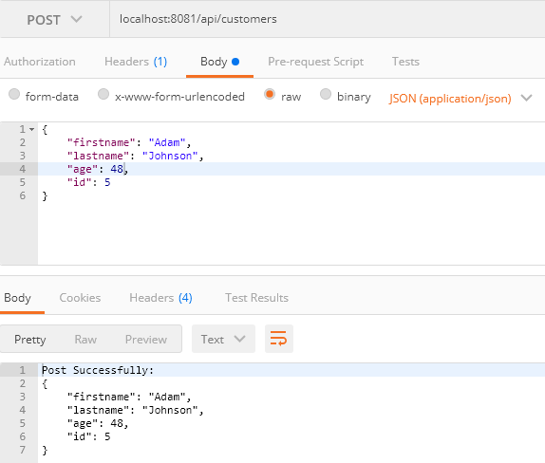

1. Put:

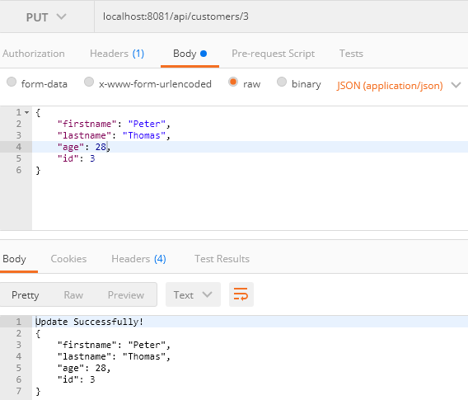

1. Delete:

